Objectives:

* Task 1: Create and configure Azure AD users
* Task 2: Create Azure AD groups with assigned and dynamic membership
* Task 3: Create an Azure Active Directory (AD) tenant (Optional - lab environment issue)
* Task 4: Manage Azure AD guest users (Optional - lab environment issue)

Architecture diagram:

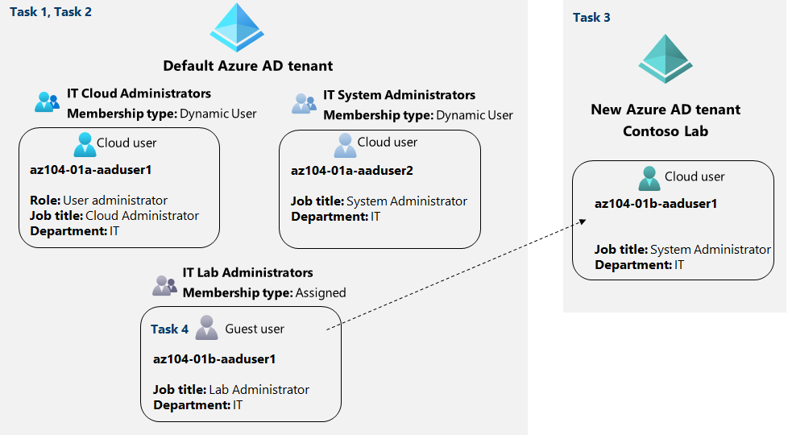

Task 1: Create and configure Azure AD users.

In this task, we will create and configure 2 new Azure AD users with the required permissions, following the settings:

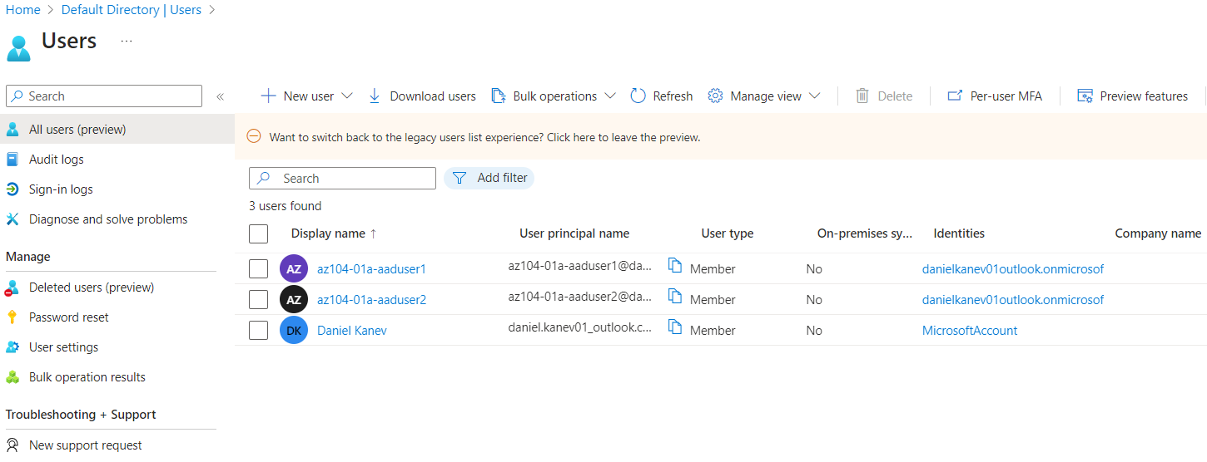

Task 2: Create Azure AD groups with assigned and dynamic membership.

In this task, we will create Azure Active Directory groups with assigned and dynamic membership:

First, we assign the **Azure Active Directory Premium P2 license to every user in the AD:**

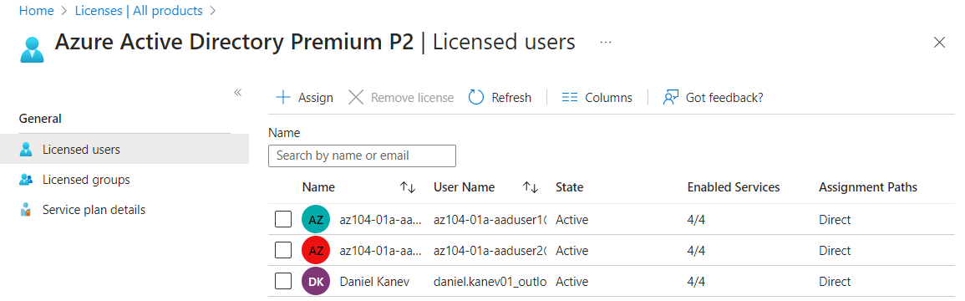

Then we create 3 new groups as per the settings:

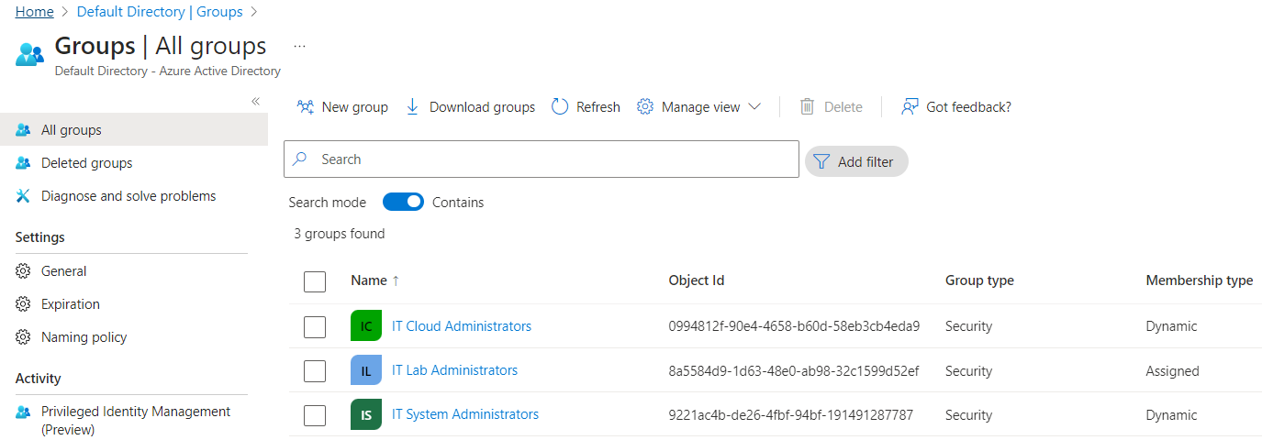

And verify that the correct users are present in **IT Cloud Administrators and IT System Administrators:**

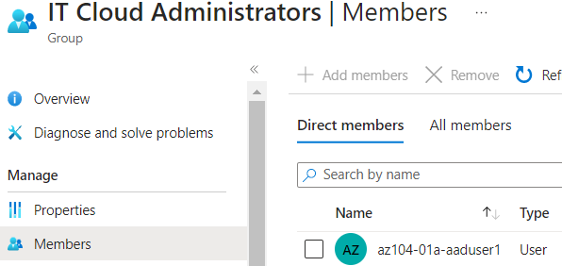

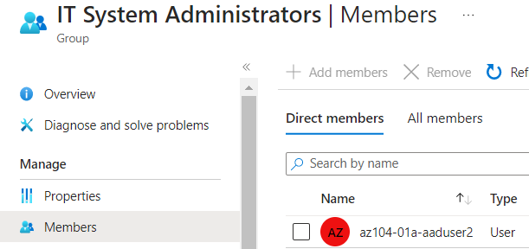

Task 3: Create an Azure Active Directory (AD) tenant (Optional - lab environment issue).

In this task, we will create a new Azure AD tenant:

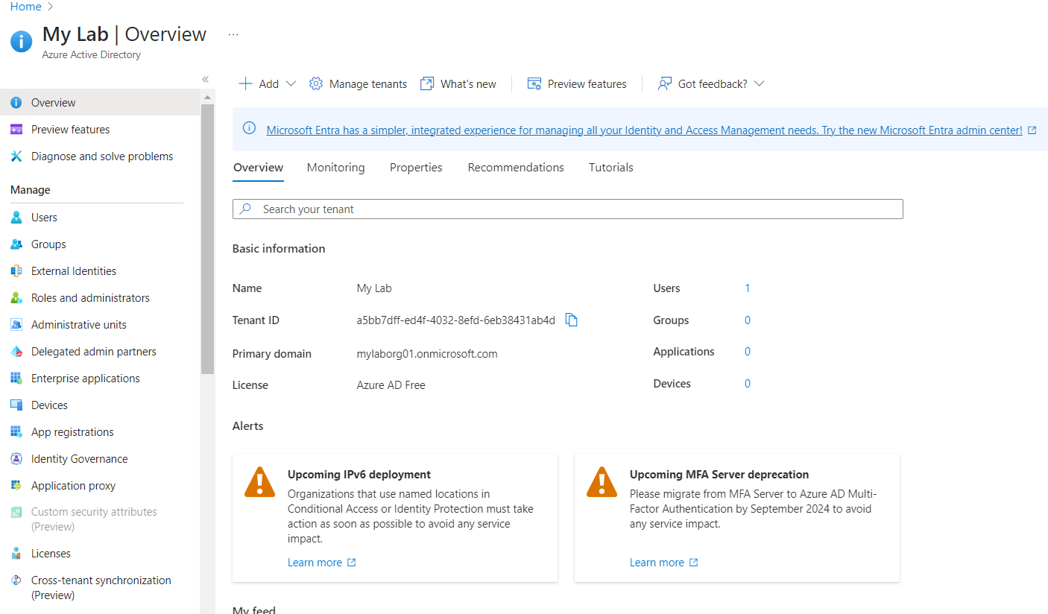

Task 4: Manage Azure AD guest users (Optional - lab environment issue).

In this task, we will create Azure AD guest users and grant them access to resources in an Azure subscription:

Here, we have to first create a new user in the Lab Azure AD tenant that we have created in the previous task:

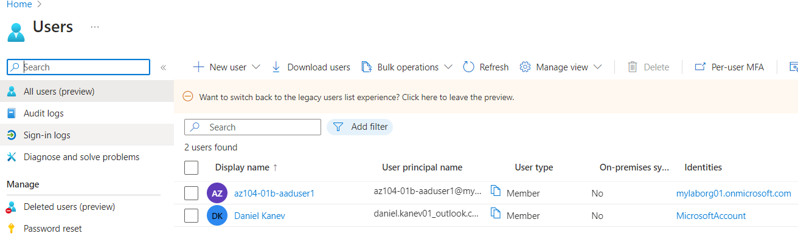

Then we switch back to our default Azure AD, invite this new user and add him to the **IT Lab Administrators** group.

